Click on a title to continue to the explanation

Overview
What is the SET Tool? What is a Marketing Mix problem?
How does the SET tool work?
What is the tool structure?
Screen Descriptions
General Screen Overview
Import
Options
Setup
KPO Spend
Historical Activity/Rx
Response Model
Interaction Terms
Lag
Rx/ Conversion Factors
Activity Costs
Reach Specification
KPO
Activity/ Spend Bounds
Other User constraints
Setting
Validate/ Optimize
High Level
KPO outputs
Detailed
Export
Glossary
Calculations
Power Model
Delta Gamma Rho Model
Interaction Model
Lag Factor Calculation
Quarter to 3 Year Calculation
Spread Factor Calculation
Year to Year Calculation
Quarter to 3 Year, Discounted Calculation
Optimization Formulation

Overview Home

What is the SET tool?

The SET tool is designed to help brand teams understand, build, and evaluate the marketing mix among various Key Planning Objectives.

What is a Marketing Mix problem?

The basic marketing mix problem asks how effort and resources can be best allocated across a given set of promotional channels. The answer to this question is dependent on the proper assessment of all possible promotion channels and the ability to accurately model activity within those channels.

How does the SET tool work? Home

Step1: The user inputs historical impact information such as financials, response parameters, historical reach/frequency of interventions, customer segment data, historical Rx data, etc.

Step 2: The tool simulates overall brand revenue and contribution impact for fully specified channel spend scenarios across key player segments.

Step 3: The user optimizes channel spend investment across key player segments under different constrained and unconstrained scenarios
    - Fixed channel investment – optimize allocation across key player (KP) segments
    - Fixed key player segment investment – optimize allocation across channels
    - Fixed brand investment – optimize allocation across channels and key player segments
    - Unconstrained – optimize overall spend and allocation across KP segments and channels

Step 4: The tool summarizes revenue and contribution results and recommended channel spend investments by key player segment for each scenario via reports and graphs in the output sections. The user is able to compare results across different scenarios

What is the tool structure? Home

The SET tool is divided into five sections.
- Brand Inputs – This section contains the structural information that is relevant to a brand including definitions of segments, groups, channels, and channel groups. Also contained in this section is division of the marketing budget into key planning objectives and marketing channels. Both the brand structure and KPO planning must remain consistent for all scenarios within the brand. However, the brand inputs section contains historical information on activity levels and reach. This data can either be used or updated as necessary for individual scenarios. While moving through the brand inputs section, a user can choose to add or remove brands.

- Scenario Inputs – This section contains all screens with data input that can be different by scenario. The response model and lag screen compile information about the total long term effect of physician responsiveness to as it varies across segments and marketing activities. The interaction terms attempt to model the added benefit or detraction a brand might see from simultaneously pursuing two different marketing channels. The final screens, of Rx/conversion factors and activity costs aggregate data on the financial impact of both performing a marketing activity and its related revenue. Within the scenario inputs section, users can choose to copy or remove scenarios.

Home
- Constraints – This section enables the user to determine the parameters by which the tool will either simulate or optimize the problem. Most of the constraints can assumed from input screens. However, new or further bounds can be created in the constraints section. When creating new constraints, the user should be careful to choose the options in the constraints section that disable historical constraints. Failure to do so will create an infeasible problem. The user should also be careful not to create conflicting constraints.

- Optimize – This section allows the user to assign specific optimization settings as well as validate and optimize scenarios. Settings for the LINGO optimizer type and initialization variables are available. Validation errors will appear on the screen, and invalid problems will not optimize.

- Outputs – This section allows the user to view the results of various optimizations and export those results to excel. Outputs can be viewed in high level, or by KPO, or in all valid dimension-metric combinations on the detailed screen.

Screen Descriptions
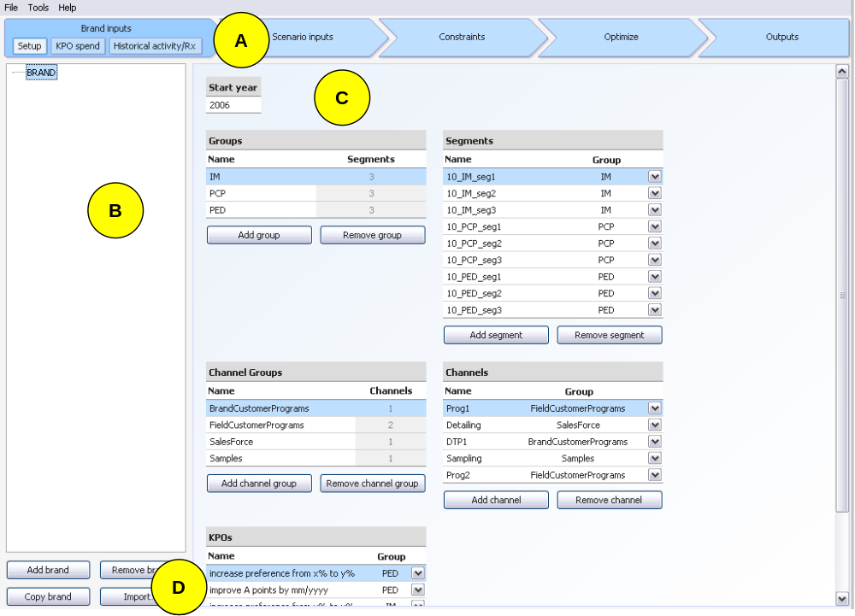

General Screen Overview Home

Pointer | Description
A | Navigation buttons allow users to open the screens within the current section or move to a different section by clicking on the section header arrow.
B | Brand/scenario listing allows users to move between various brand and scenarios.  The following user descriptions will all focus on section C of each screen
C | Data entry tables appropriate to each screen allow users to enter all data inputs and view optimization outputs.
D | Brand/ scenario buttons allow addition/removal brands and scenarios. The import function allows user to add scenario from another file.

Scenario Import Home

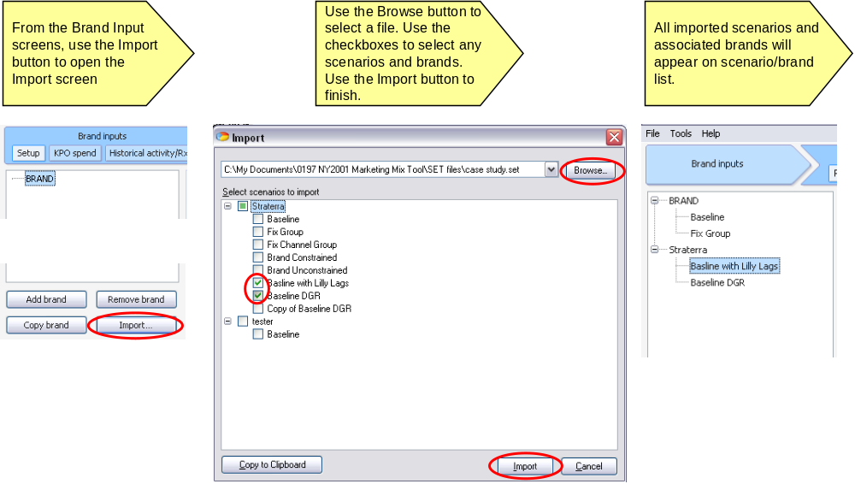

Options Home
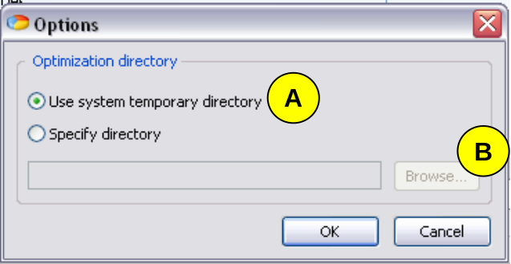

Pointer | Description
A | The SET tool will generate multiple files during the optimization. The user must choose a folder in which to hold these folders. The default folder is the Temp Folder.
B | The user can use the browse button to pick a specific folder for generated files.

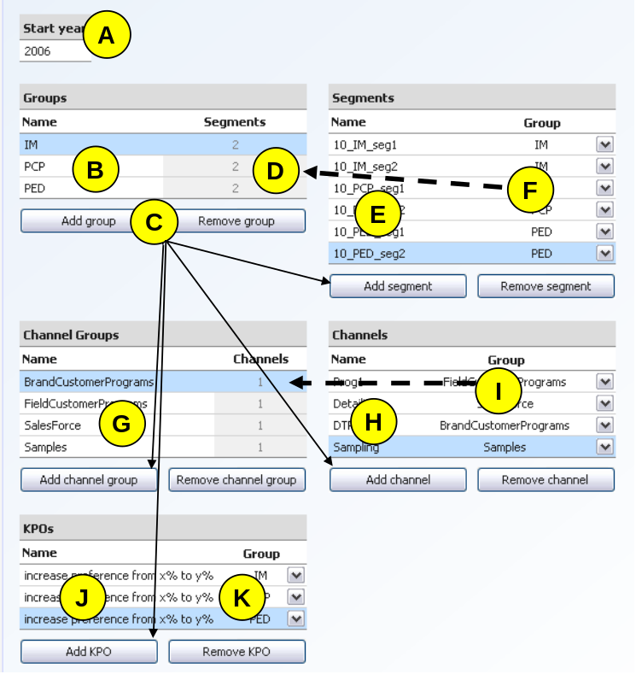

Screen: Brand Inputs → Setup Home

Pointer | Description
A | The start year is the year in which all marketing activities will take place. This will only have an effect on the output table labels.
B | Groups represent clusters of segments, and are usually doctor types i.e. PCP, PED. Enter unique group names that will be the object of listed KPO activities
C | Add/Remove buttons allow users to control the number of groups/segments/etc in the model. Elements added on the Setup page will be reflected throughout the tool.
D | Displays the total number of segments in each group, or channels in each channel group. The user can change the values in these cells by adjusting the linkages in segment and channel tables respectively. This total serves as a validation and is not used in the tool.
E | Segments represent the most discreet form of customer division. Many data entry levels are done at the segment level.
F | Segments must be linked to a larger Group. The drop-down boxes list all available groups, and automatically update when group names are changed. Segments must be unique.
G | Channel groups are the larger clusters of channels which relate similar marketing activities. KPO activities are entered at the Channel Group level. Channel groups must be unique
H | Channels refer to specific marketing channels. Channels must be unique
I | Channels must be linked specifically to Channel Groups. Many linkages will be 1 to 1 relationship.
J | Key Planning Objectives are specific marketing goals that will be achieved through the marketing channels.
K | KPO’s must be linked to Groups. Each KPO x Group combination must be unique.

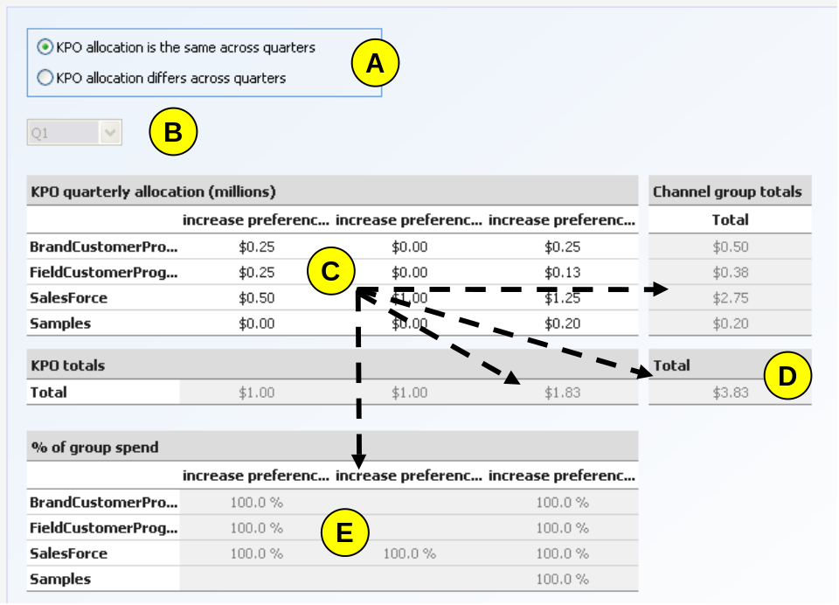

Screen: Brand Inputs → KPO Spend Home

Pointer | Description
A | If KPO allocation is the same across quarters, then the marketing expenditure the same in Q1 through Q4 for each KPO x Channel Group point. This option will grey-out the quarter drop-down.  If KPO allocation is different in any quarter, then all four quarters’ data must be entered.
B | The Quarter drop down only appears if KPO allocation differs across quarters. A different data entry table (pointer C) is linked to each quarter. KPO’s must be entered for all quarters.
C | The estimated marketing expense must be entered in positive quarterly millions by KPO x Channel Group, even if the expenditure is the same across quarters. An empty cell is interpreted as a zero.
D | The estimated quarterly expenditure is totaled for each KPO and Channel Group, and for the brand as a whole. These values can only be adjusted in the data table and are for validation purposes.
E | The percent of each Group’s revenue from a given Channel Group that will be attributed to each KPO is calculated and displayed below.

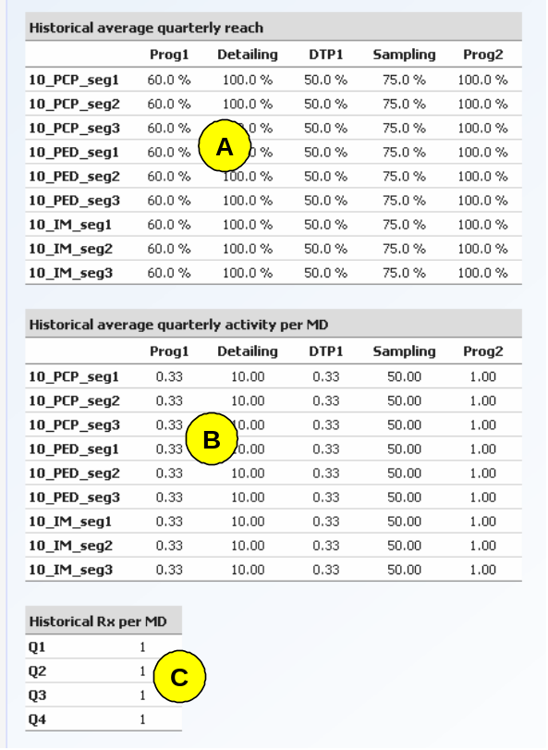

Screen: Brand Inputs → Historical Activity / Rx Home

Pointer | Description
A | The historical average quarterly reach must be entered in positive percents by Channel x Segment. This represents as observed historical reach for each quarter. It used as an estimate of current year reach unless otherwise specified in the Reach Constraints Page.
B | The historical average quarterly activity per MD must be entered in positive numbers by Channel x Segment. This represents as observed historical activity for a single MD in each quarter. It is not used in the tool as an estimate of current year reach.
C | The Historical Rx per MD is the average number of Rx’s each MD will write in each quarter in response to an equal level of marketing support. This positive, numeric value is also used to calculate the quarterly adjustment factor that estimates the relative seasonal effect of equivalent marketing support unless otherwise specified on the Response Model Page.

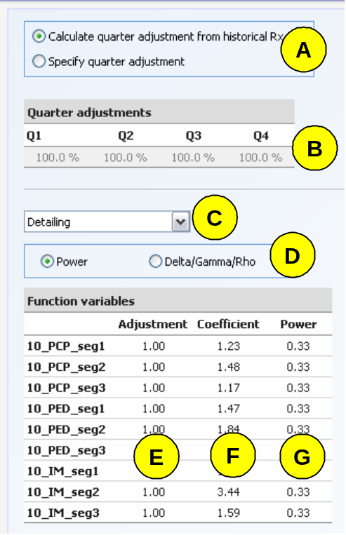

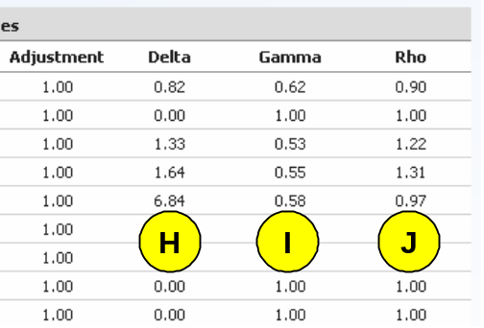

Screen: Scenario Inputs → Response Model Home

Pointer | Description
A | The quarterly adjustment factor can either be calculated from historical Rx or be entered directly by the user.
B | If the user chooses to calculate the quarterly adjustment, the historical Rx per MD is normalized to 400%. For example, if the same number is in each quarter, the quarterly adjustment will be 100% for each quarter.  If the user enters values, entering 100% in each quarter means that there is no seasonal effect on MD response. A positive numeric value must be entered for each quarter.
C | The response model must be entered in positive numeric values for each Channel x Segment.
D | The MD response can either be modeled using a power function or a delta gamma rho model. Model type can vary by channel, but not by segment. Please see the appendix for a further explanation of each model.
E | Both response model types can include a positive numeric adjustment factor. This adjustment factor must be the same across all quarters but can vary or each Channel x Segment. An adjustment factor of 1 implies that the entered response model is an accurate description of MD behavior.
F | The coefficient term in the power model. Please see the appendix for a further explanation of each model. A positive numeric value must be entered for each segment.
G | The power term in the power model. Please see the appendix for a further explanation of each model. A positive numeric value less than 1 must be entered for each segment.
H | The delta term in the delta gamma rho model. Please see the appendix for a further explanation of each model. A positive numeric value must be entered for each segment.
I | The gamma term in the delta gamma rho model. Please see the appendix for a further explanation of each model. A positive numeric value must be entered for each segment.
J | The rho term in the delta gamma rho model. Please see the appendix for a further explanation of each model. A positive numeric value must be entered for each segment.
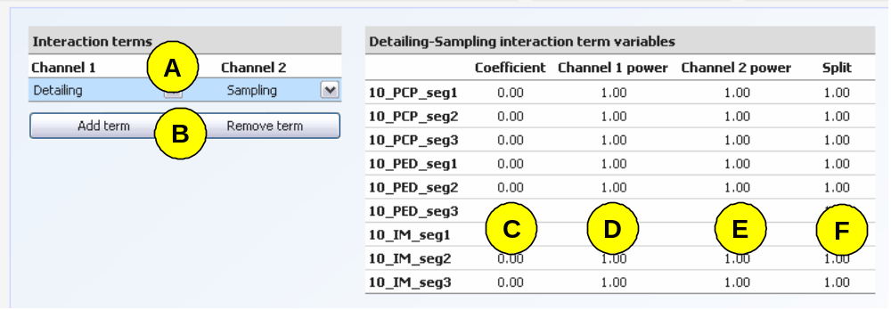

Screen: Scenario Inputs → Interaction Terms Home

Pointer | Description
A | To create an interaction, two channels must be chosen from the existing list.
B | The Add/Remove buttons allow users to enter or delete interactions from the scenario. An interaction term is not needed for the tool to operate.
C | The coefficient term is entered from the interaction response model. Please see the appendix for further explanation of the model. A positive numeric value must be entered for each segment.
D | The first channel power term is entered from the interaction response model. Please see the appendix for further explanation of the model. A positive numeric value must be entered for each segment.
E | The second channel’s power term is entered from the interaction response model. Please see the appendix for further explanation of the model. A positive numeric value must be entered for each segment.
F | The split term refers to the first channel’s share of the revenue created by the interaction. A positive numeric value must be entered for each segment.

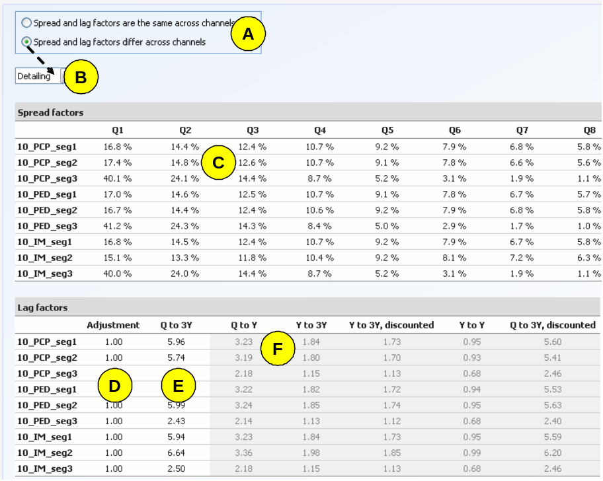

Screen: Scenario Inputs → Lag Home

Pointer | Description
A | To spread and lag terms can either be used for all channels or vary by channel. If the user chooses to enter different values by channel, each channel’s values must be entered.
B | The drop down allows users to enter data by channel. It will only be shown if the user chooses to vary values by channel.
C | The spread factors are percentage of total quarter to 3 year lag that is attributed to each quarter. Positive numeric values should be entered for each segment. The sum of spread factors for quarters 1 through 12 must be 100%. Please see the appendix for further explanation on the calculation of spread factors.
D | The lag adjustment factor allows users to adjust the historically calculated quarter to 3 year lag term. An adjustment factor of 1 implies that the entered lag term is correct. A positive numeric value should be entered for each segment.
E | The quarter to 3 year lag term is the total multiplier of revenue from each quarter to the 3 subsequent years. A positive numeric value less than 12 must be entered for all segments.
F | The grey cells show values calculated from the quarter to 3 year lag. Only the quarter to 3 year discounted lag term is used in the tool. Please see the appendix for a further explanation of the calculation.

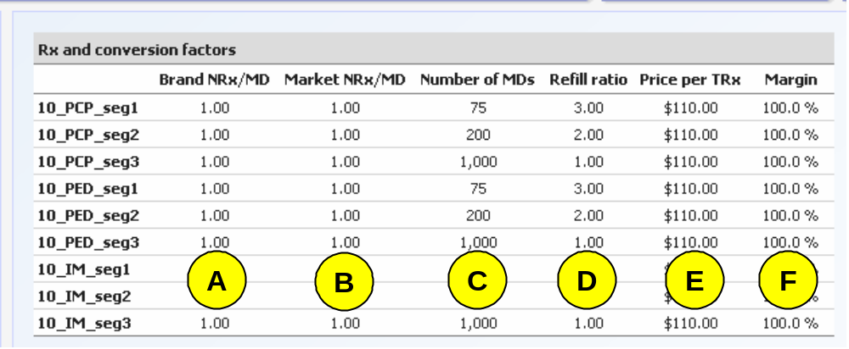

Screen: Scenario Inputs → Rx/ Conversion Factors Home

Pointer | Description
A | The Brand NRx serves as a historical comparison or validation point. It is not used in the optimization
B | The Market Nrx / MD is the estimated NRx multiplier from each response. A positive numeric value should be entered for each segment.
C | The number of MD’s is the estimated total count that will be targeted in each segment. A positive numeric value should be entered for each segment.
D | The refill ratio is the estimated multiplier of total prescriptions that will be filled from each new prescription (also known as TRx). A positive numeric value should be entered for each segment.
E | The price per TRx is the revenue that is gained from each prescription filled. A positive numeric value should be entered for each segment.
F | The margin is the estimated percentage of revenue that will be gained from each prescription. A positive numeric value less than or equal to 100% should be entered for each segment.

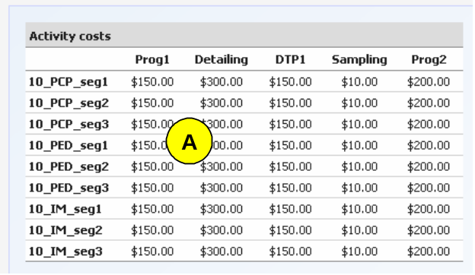

Screen: Scenario Inputs → Activity Costs Home

Pointer | Description
A | The activity costs the total expenditure necessary for each instance of effort in a marketing channel. A positive numeric value should be entered for each Channel x Segment

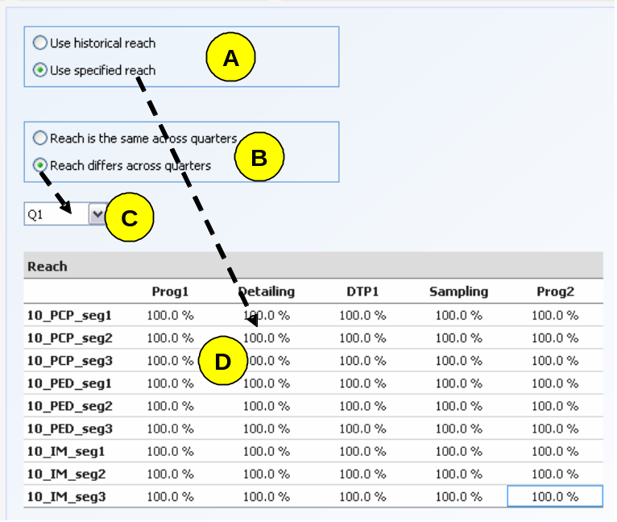

Screen: Constraints → Reach Specification Home

Pointer | Description
A | The user can choose to use historical reach from the Historical Activity/ Rx screen, or specify a reach. All of the following sections will greyed-out unless the user chooses to specify reach.
B | The user can choose to either specify the same reach for all quarters or vary specified reach by quarter.
C | The drop down box allows users to enter values for each quarter. It will remain greyed-out unless the user chooses the specify reach by quarter.
D | A positive numeric value less than or equal to 100% must be specified for each Channel x Segment.

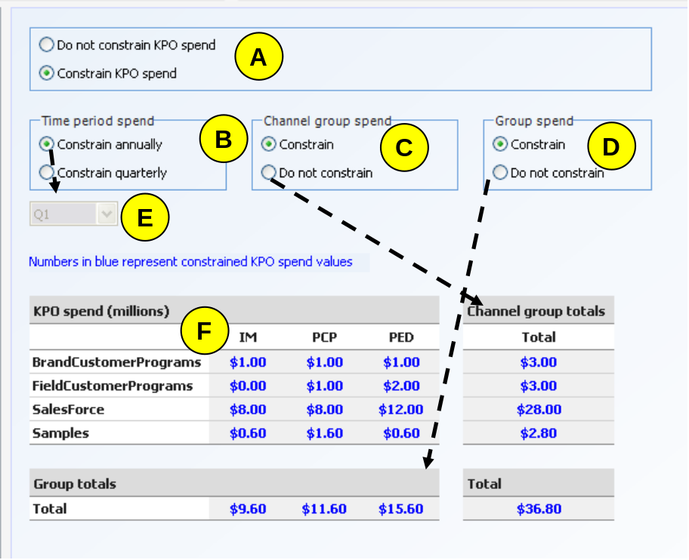

Screen: Constraints → KPO Home

Pointer | Description
A | The user can choose to constrain KPO spend, or not to constrain KPO spend. If “constrain KPO spend” is chosen, the Total Spend is highlighted in blue.
B | The user can choose to constrain KPO annually (the sum of all 4 quarters) or quarterly, (using each quarterly separately).
C | The user can choose whether to constrain KPO spend by Channel Group.
D | The user can choose whether to constrain KPO spend by Group.
E | If the user chooses to constrain KPO by quarter, the user can choose quarters using the drop down menu.
F | The text in the grey cells will appear blue if the value is a constraint.

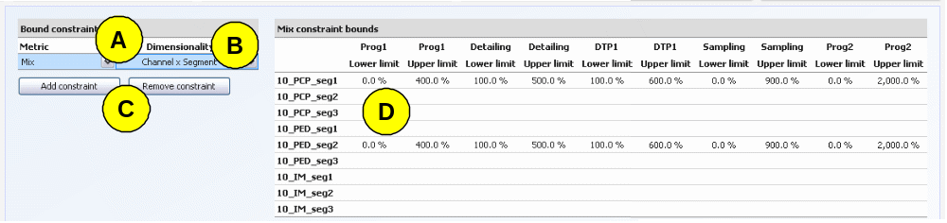

Screen: Constraints → Activity / Spend Bounds Home

Pointer | Description
A | The user must choose a metric by which to enter the constraint. Please see the glossary for further definition of the metrics.
B | The user must choose an associated dimensionality by which to enter the constraint.
C | The add/remove buttons are used to create or delete constraints.
D | The user may enter as many positive numeric upper and lower bound constraints as necessary. A cell left blank will not be used as a constraint; a zero must be entered to indicate a bound of zero. To create a simulation situation, both the lower and upper bound can be set to equivalent values. To create an optimized solution, the lower and upper bounds should be set to non-equivalent values.

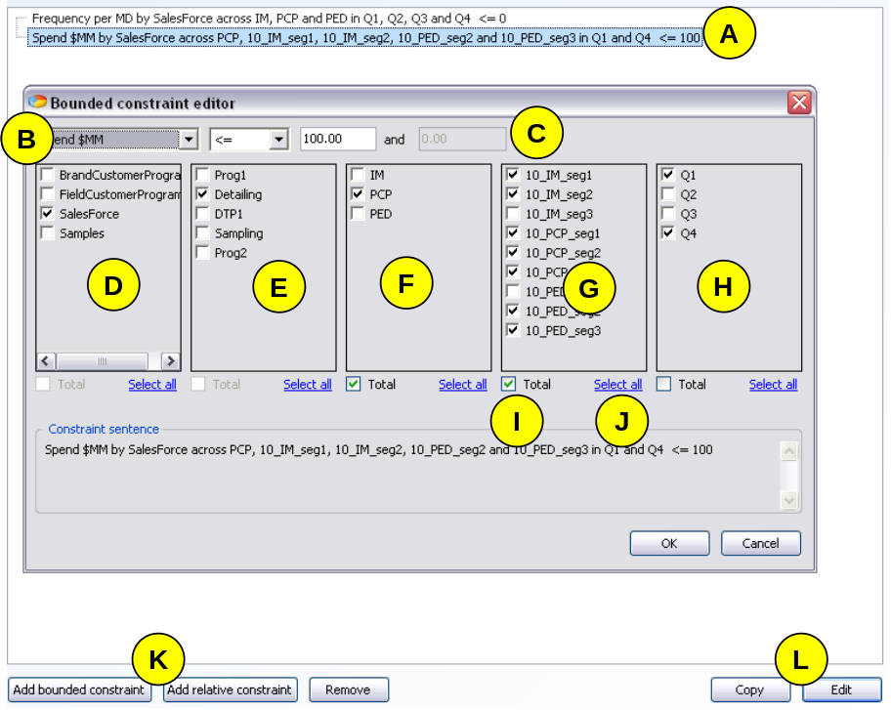

Screen: Constraints → Other Home

Pointer | Description
A | The user can view all added bounded and relative constraints in a list.
B | The drop down menus can be used to choose a bounding metric and the equality (greater than, less than, or between).
C | The user must enter the constraint bounds or multipliers (in the case of a relative constraint)
D | The user can choose which, if any, channel groups to include in the constraint. Choosing a channel group will automatically choose all associated channels.
E | The user can choose which, if any, channels to include in the constraint.
F | The user can choose which, if any, groups to include in the constraint. Choosing a group will automatically choose all associated segments.
G | The user can choose which, if any, segments to include in the constraint.
H | The user can choose which, if any, quarters to include in the constraint.
I | The user can choose for the constraint to apply either as a total of the chosen elements, or to apply to each combination using the chosen elements. The default for bounded constraints is to apply to each, whereas the default for relative constraints is to apply as a total.
J | The user can choose to choose all elements within a grouping.
K | The buttons can be used to open either a blank bounded constraint editor or a blank relative constraint editor. The remove button deletes a chose constraint from the list.
L | The buttons can be used to copy or open the editor for a constraint already in the list.

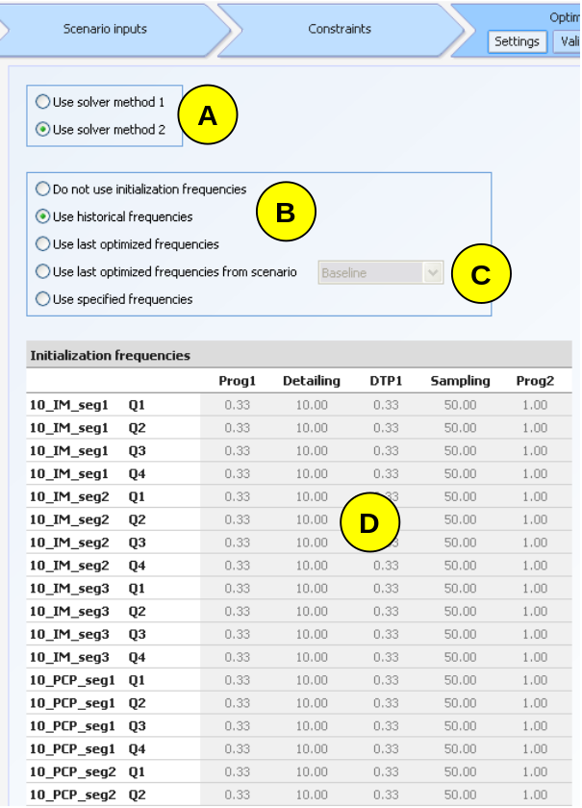

Screen: Optimize → Settings Home

Pointer | Description
A | The user can choose to either use solver method 1 or solver method 2. Solver 1 is an older version and is only recommended for use if solver 2 repeatedly fails.
B | The buttons can be used to choose a frequency initialization method. Historical frequencies links to the historical activity table. Choosing to use frequencies from a specific scenario will unlock the drop down menu.
C | The drop down menu can be used to choose from the scenarios which have output frequencies in the current setup.
D | The table displays the chose initialization frequencies.

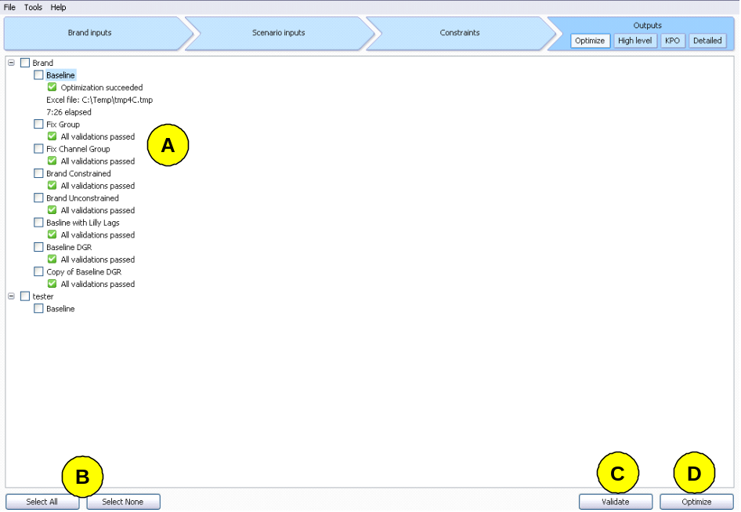

Screen: Optimize → Validate/Optimize Home

Pointer | Description
A | All scenarios and brands in the scenario are listed. All performed operations will only apply to selected scenarios.
B | The buttons can be used to either select or unselect all scenarios.
C | The validate button validates the entered data for all selected scenarios. All errors appear in red text below the scenario name.
D | The optimize button is used to run the tool. The file is saved after each optimization, and results become visible in the output screens.

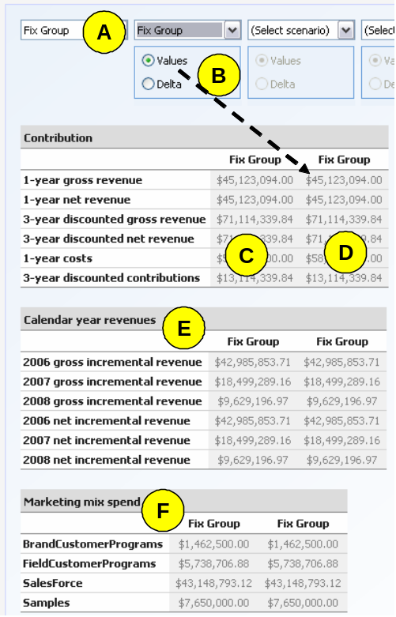

Screen: Outputs → High Level Home

Pointer | Description
A | To view high level information from the outputs, the user must first choose which scenarios to view. The user may choose up to five scenarios to compare at a time. The far left scenario is the base scenario, and all other scenarios are compared to the base.
B | Scenarios can either be compared using absolute values or difference from the base scenario (chosen scenario minus base scenario)
C | The values of the base scenario are listed in the far left column of the 3 year contribution table
D | The remaining columns show either absolute values or differences from the base scenario.
E | The second table shows values for the calendar year revenues
F | The third table shows values for the marketing mix spend.

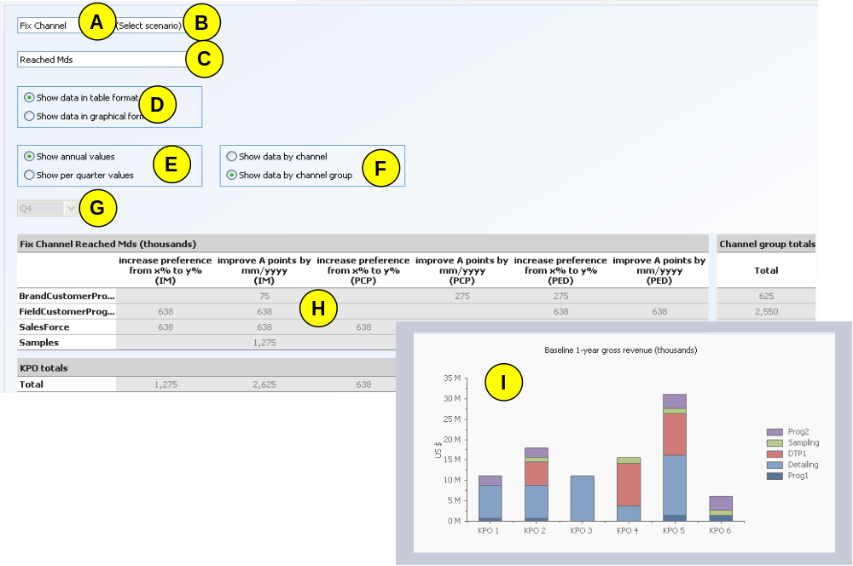

Screen: Outputs → KPO Home

Pointer | Description
A | To view KPO information from the outputs, the user must first choose which scenarios to view. The user may choose two scenarios to compare at a time. The top table is the base scenario’s output.
B | To view KPO information from the outputs, the user must choose which scenarios to view. The user may choose two scenarios to compare at a time. The bottom table is the second scenario’s outputs.
C | The tables below will show the metric chosen from the drop down menu.
D | The user can choose to show the KPO information in a table or graph.
E | The user can choose to show annual or quarterly values. Choosing quarterly values will unlock to quarter drop down menu
F | The user can choose to show the KPO information for channel or channel group.
G | The user choose which quarter to view using the drop down menu.
H | The table shows the output values.
I | The graph shows the output values.

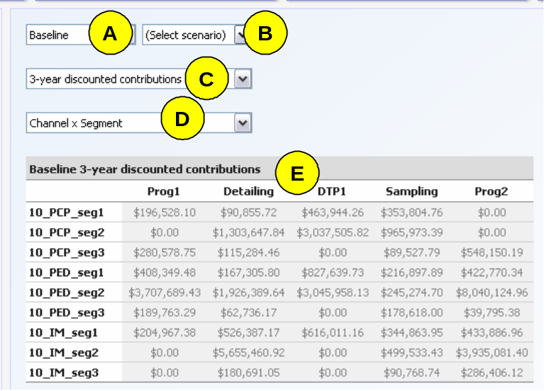

Screen: Outputs → Detailed Home

Pointer | Description
A | To view KPO information from the outputs, the user must first choose which scenarios to view. The user may choose two scenarios to compare at a time. The top table is the base scenario’s output.
B | To view KPO information from the outputs, the user must choose which scenarios to view. The user may choose two scenarios to compare at a time. The bottom table is the second scenario’s outputs.
C | The tables below will show the metric chosen from the drop down menu.
D | The tables below will show the outputs by the dimensions chosen from the drop down menu. The list of available dimensionalities is linked to the choice of metric.
E | The table shows the output values.

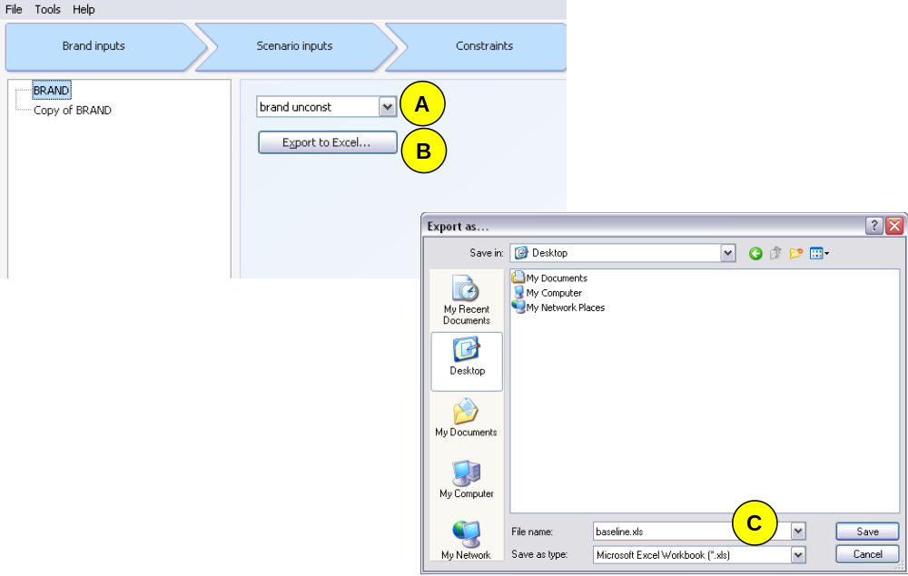

Screen: Outputs → Export Home

Pointer | Description
A | The drop down menu can be used to choose a scenario whose data to export.
B | The button can be used to open an explorer window.
C | Choose a file name and location for the excel outputs.

Glossary Home

Activity – The accumulated instances of use of a marketing channel across a given number of customers
Brand NRx – The historical brand level NRx. It is not used in the tool.
Channel – The categorization of marketing effort necessary to reach a customer group
Channel Group – The larger grouping of channels similar in resource use
Constraint – A limitation of solution possibilities
Contribution – Often interchangeable with profit, the revenues generated by marketing less spend
Delta Gamma Rho Model – An equation used to represent physician responsiveness to marketing effort. The model can be used to represent S-shaped curves. Please see calculation section for equation form
Discounted values – The valuation of future values in present value terms using a discount rate
Discount Rate – The interest rate used in calculating the present value of expected yearly benefits and costs
Export – To copy results to an independent excel worksheet
Frequency – The given number of times a marketing activity takes place in a given quarter
Gross revenue – The total sales garnered in a given period of time
Group – A larger collection of multiple segments into physician types
Historical Rx per MD – The number of new prescriptions written by a physician for every unit of response to marketing effort
Incremental Revenue – The portion that of total revenue that can be attributed to a given period of time
Initialization – The feeding of starting values to the LINGO tool in order to speed the calculation process and avoid incomparable local optimals
Interaction – The additional benefit or detriment that is the result of simultaneously conducting two related channels
KPO – The Key Planning Objectives are the initiatives that the brand team intends to undertake. All KPO’s are associated with a specific group of physicians
Lag Factor – The portion of sales in a given quarter that can be attributed to the first quarter relative to the real sales of the first quarter. Please see calculation section for further explanation
Margin - The percentage difference between the price received for a product and its production cost
Market NRx (Volume) – The total new market prescriptions that a single physician will write in response to one unit of marketing effort
Market NRx (Share) – The total new market prescriptions written by all physicians in the market in response to marketing effort
Mix – The percentage of total spend that is spent on each channel, segment, or other division
Net Revenue – The sales in a given period less the cost of goods sold
NRx – The new prescriptions written by a physician
Optimization – The allocation of resources and effort as efficiently as possible
Power Model – An equation used to represent physician responsiveness to marketing effort. Please see calculation section for equation form
Home

Q to 3Y term – The cumulative multiplier of sales generated by a given quarter going three years forward

Reach – The percentage of total physicians in a total group that the marketing channel will touch
Refill Ratio – The average multiplier of total prescriptions filled from every one prescription written
Revenue – The total sales generated in a given time period
Segment – A grouping of physicians, generally by physician type and product preference
Spend – The total financial cost accumulated in a given time period
Spread factor – The percentage of the Q to 3Y term than can be attributed to a specific quarter
TRx – The total prescriptions filled by a patient from one written prescription
Validation – The process by which all data entered is checked for logic
Year to Year – The cumulative multiplier of sales generated by all quarters from one year to the next

Calculations Home

Power Model
The Power response model is also commonly known as the Alpha-Beta response model. It is characteristically used to represent diminishing return or concave curves. It is of the form:
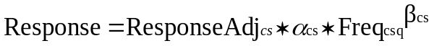

The alpha, or coefficient term, determines the overall height of the curve. The beta, or power term, determines the shape or rate of change of the curve including the how quickly the curve will diminish; effectively shortening or lengthening the curve. The response adjustment term allows users to more accurately represent how this average curve relates to each quarter. All terms are unique by Channel and Segment.

Delta Gamma Rho Model: Home
The Delta-Gamma-Rho response model is a common mathematical representation of the response model. It is most often used to represent diminishing return or concave curves, but has the added ability to represent s-shaped curves. It is of the form:

The delta, or coefficient term, determines the overall height of the curve. The gamma, or power term, determines the shape or rate of change of the curve including the how quickly the curve will diminish; effectively shortening or lengthening the curve. The rho term allows the curve to have an inflection point and thereby create s-shaped curve. The response adjustment term allows users to more accurately represent how this average curve relates to each quarter. All terms are unique by Channel and Segment.

Interaction Model:
The interaction model is designed to represent the added benefit or detriment to the brand by simultaneously pursuing two related marketing channels.

The interaction alpha value is based on the multiplier of the effect o the interaction. The beta value is the power term which allows the curve to take on a diminishing or concave shape. The function is multiplied by the minimum of the reaches between the two interacting channels because that is the maximum umber of physicians who were touched by both channels in the given time period. The total revenue value from this interaction is then divided amongst the two interacting channels.

Lag Factor Calculation: Home
The lag term calculation is based on the theory that marketing effort in a given time period will have sales results not only in that time period but also in subsequent time period. The level of that long term effect, however, can be very different between physician groups, brands, and marketing channels.
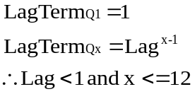

In the lag factor calculation, the lag term in Q1 always equals 1 because the sales in Q1 are fully attributable to the marketing effort in Q1. The marketing effort in Q1 has an exponentially diminishing effect on each subsequent quarter.
Quarter to 3 Year Calculation: Home
The quarter to three year calculation is the cumulative multiplier of sales generated by a given quarter going three years forward.
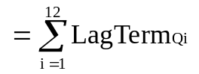

Spread Factor Calculation:
The spread factor for any given quarter is the percent of the cumulative multiplier (of sales generated by the first quarter) that is attributed to that quarter.

Year to Year Calculation: Home
The year to year calculation is the cumulative multiplier of sales generated by all effort quarters from one year to the next.
where

Quarter to 3 Year, Discounted Calculation: Home
The quarter to 3 year discounted calculation attempts to both understand the long term effect of marketing effort in a given quarter while also accounting for the present value of that revenue.

The equation uses a yearly discount rate in a typical present value function.

Optimization formulation: Home

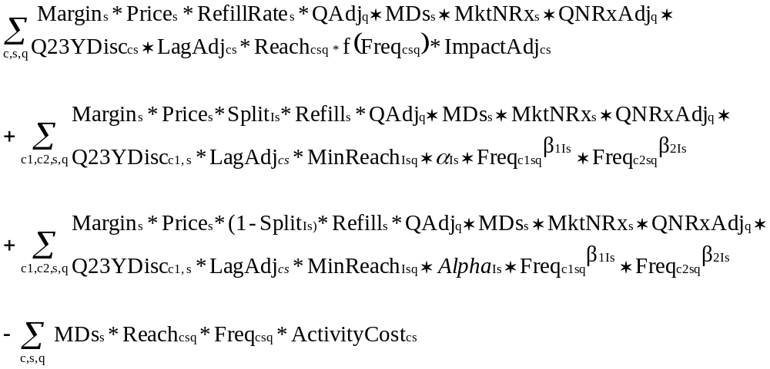
Revenue:

Interaction
for Channel 1:

Interaction
for Channel 2:

Cost:

